# COMP3000 Computing Project

## 2021/2022

### Project Title

Language learning app using an AI implementation of the Leitner system.

### Links

Source code:<https://github.com/Zedster82/Comp-3000>

### Project Vision

My application will be for users that have access to a phone, being android or iOS, or web users that will have access to a browser.

It will aim to solve the difficulties of learning a new language.

The name of my project will be Leitner Language Learning.

It is an application that focuses on language learning via the use of the Leitner System with flash cards. This will help users be able to learn a language quicker as their learning will be focused and personal, therefore more efficient.

### *Risk Plan Chart*Risk Plan

### Proposed Gantt chart

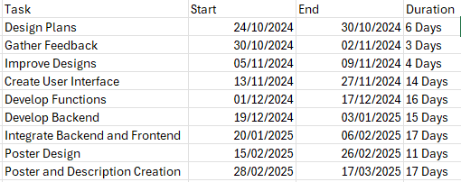

### Keywords

AI, Leitner System, Language, Learning, React Native, JavaScript